Sensory Cookery  Shopping for ingredients, learning about recipes, weighing, measuring, experiencing, using a switch to whisk, social skills  PSHE – Building confidence, opportunities for communication about a range of topics linked to PSHE | Aquatics  Incl. differentiated and age-respectful activities in the water, working with the Aquatics team and Physiotherapists  PSHE – body awareness, building confidence, communication opportunities |  |  | Multi - Sensory Studio  Students can choose from a variety of sensory stimuli activities,  work on sensory awareness  themed sessions  PSHE – body awareness |  |  | Patchwork Farm  Our own onsite farm gives students a range of opportunities for learning through things that ‘move and grow’ outdoors - and even in the classroom  PSHE – building confidence, communication opportunities
 |  |  |  | 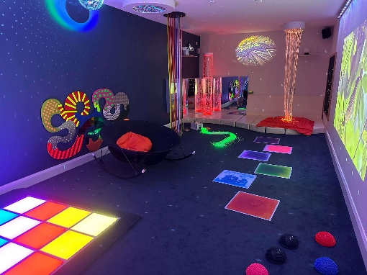 |  |  | 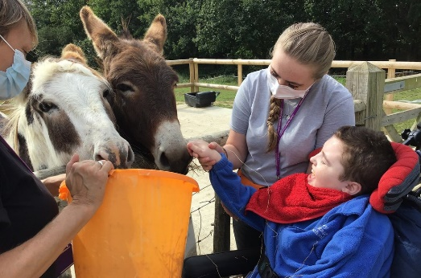
Lunchtimes  Learning activities take place throughout the day, including at lunchtimes. Lunchtimes offer opportunities to develop independence and social awareness and celebrate too!  PSHE – communication opportunities – how do I feel today? |  |  | Sensory Learning  Many of our students learn about themselves and the world around them via their senses. This includes use of personalised Tac Pac and Guided Mindfulness  PSHE – Building confidence, body awareness |  |  | Rebound  Opportunities to feel their bodies move in different ways and feel the effects of their own independent movements – now in the DREAM Centre  PSHE – body awareness, building confidence |  | Specific Learning  Students, in line with Next Steps, work on numeracy and literacy skills – building on previous learning. Structured, varied resources help to keep the learning opportunities fun and stimulating  PSHE – building confidence, communication skills
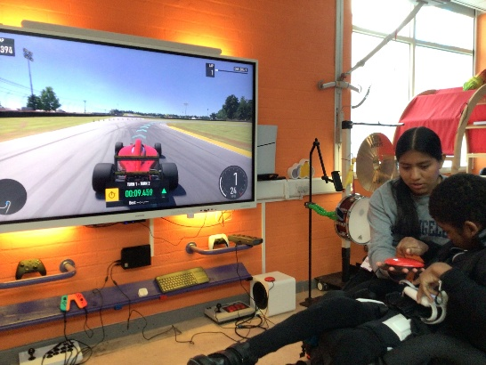 |  | 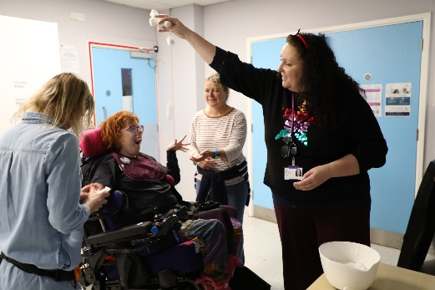 |  |  | 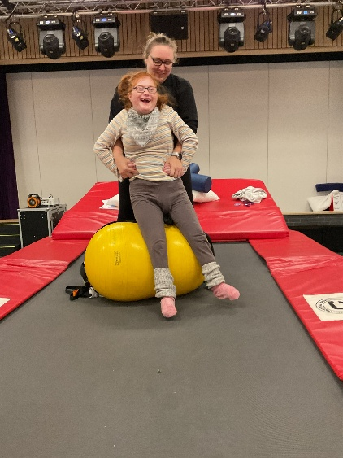 |  |  | 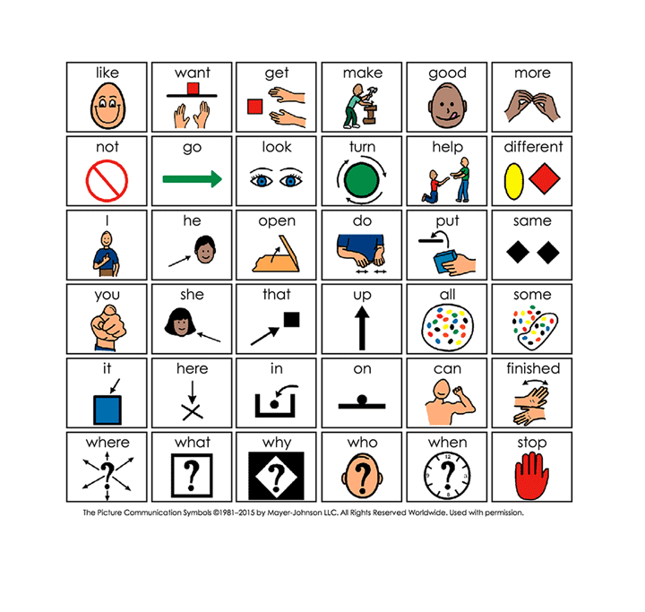

Makaton  Makaton is a unique language programme that uses symbols, signs, and speech to enable people to communicate. We work this into support communication, wherever appropriate  PSHE – Awareness of the wider environment, Building confidence | Pony Management and Riding  Hanbury students have regular opportunities to spend time with the ponies, feeding, grooming, enjoying being at the stables. Some students can ride and are supported to do so  PSHE – building confidence | PSHE and RSE  Students work towards developing awareness of physical, emotional, and sexual development, and personal safety. We give students the information they need to develop healthy nurturing relationships of all kinds. |  |  | Music  Music sessions focus on team work, creativity, multi-sensory experiences and freedom of expression. Music is also part of AAC (Alternative Augmentative Communication)  PSHE – building confidence
 | 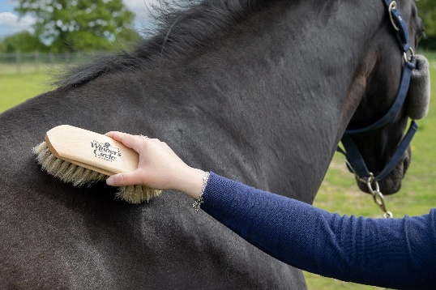 | 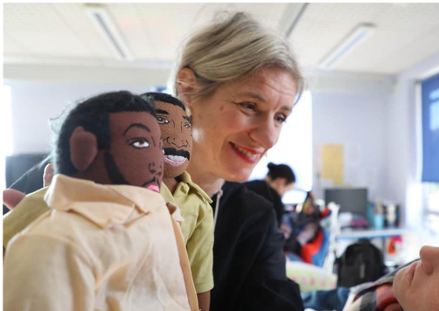 |  |  | 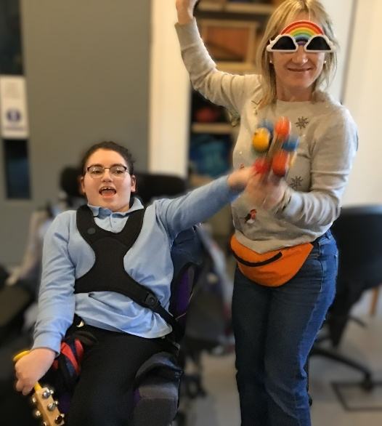
Social  Gossip magazines, Hanbury Student Council, shopping rounds, chat groups, 1:1 chat time are facilitated by teachers and therapists to ensure that the students get a chance to enjoy the company of their peers  PSHE – building confidence, self -awareness, communication opportunities | Driving, Walking and Biking  Students either drive their own powered chairs using switches or drive their wheelchair on a platform base using a connecting switch – also regular bike riding for those who need and enjoy this  PSHE – building confidence, body awareness – what can I do with my switches |  | Therapies  Therapy sessions conducted by specialists (Physio, SALT, OT) are woven into the daily timetable for each student  Eye Gaze  Music  Massage  Powered Mobility  Hydrotherapy |  |  |  | Individual Project Work  Students are supported to work on their own different projects where meaningful and appropriate for them, for example, investigating future destinations for after Chailey, writing a blog or running a Gossip Magazine.  E-Safety is a priority for all students who have access to computers  PSHE – building confidence, self -awareness, communication opportunities
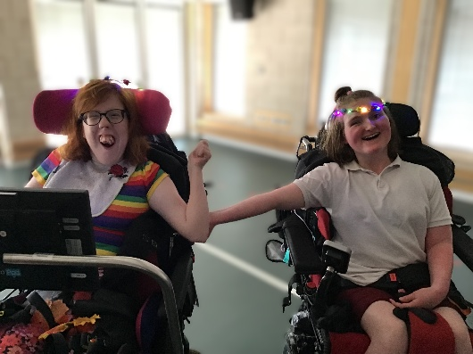 | 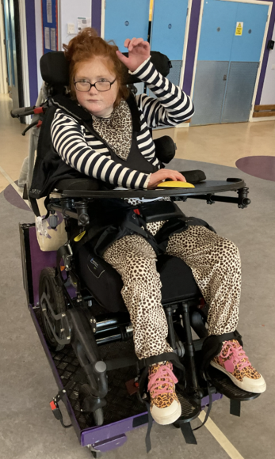 |  | 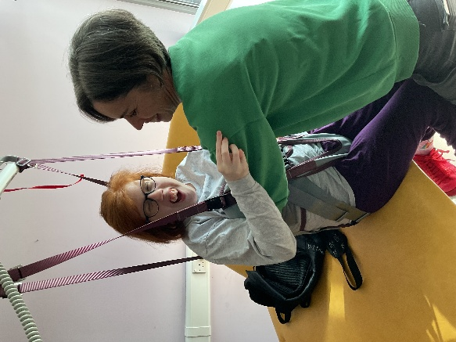 |  |  |  | 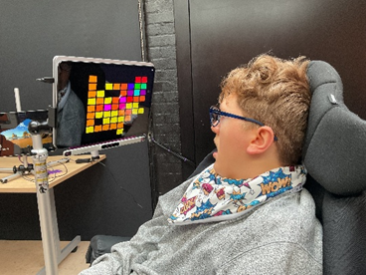
Personal Stories  Developing awareness of own values, interests, skills –identity and sense of self, understanding feelings, learning how to express these – who am I and what is important to me?  PSHE – what are the roles of other people in relation to me?  What is it okay to do/not okay to do with these different people? | Drama  The Circus  The Drama Circle  Students write their own play  Costumes, lighting, auditions – it’s all part of our Drama programme  PSHE – Role play enabling exploration and expression of different and more complex emotions |  |  | Outings  Students can use VOCAs, switches and CCS when they are out and about. Outings introduce variety and enrichment as well as opportunities to develop skills  PSHE – communication opportunities throughout |  | Celebrations  Special occasions are marked wherever possible, involving as many as staff and students as we can in whatever way we can. Being a part of something amazing  PSHE – communication opportunities – what are the roles of others in relation to me?
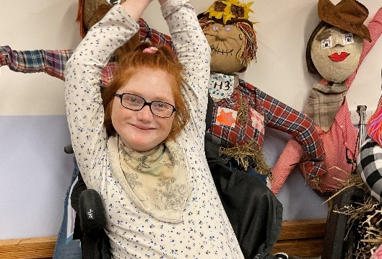 | 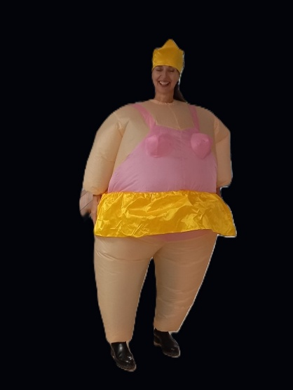 |  |  | 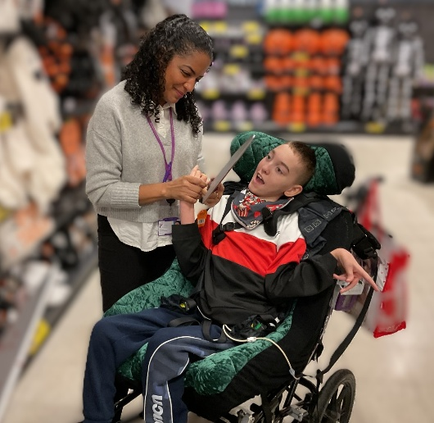 |  | 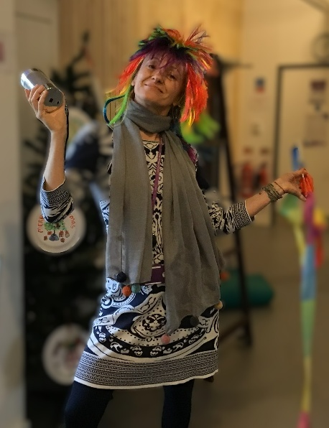
The Hanbury Pantomime  Students audition for roles, write their parts, showcase their skills, decide on the music, choose their costumes, dress up – a fresh and creative approach. It is a Chailey tradition!  PSHE – exploration of feelings in the context of Drama  Building confidence | Visitors  Roedean School CAP  Role models with disabilities  Make a Difference Day  Ed Boxall, Poet  Work Experience Students  PSHE – Developing empathy for others, communication with a wide range of people, awareness of the wider environment |  | Seasonal Activities  The Hanbury Pantomime  The Summer Ball  Snowball Fights  Hallowe’en Party  Santa Dash  Pancake Flipping  PSHE – developing friendships and relationships |  |  | Whole School Activities  ChaileyFest  Celebration Day  ‘Saying Goodbye’ Events  Christmas Markets  Singing Hands  Makaton Choir  PSHE – developing friendships and relationships
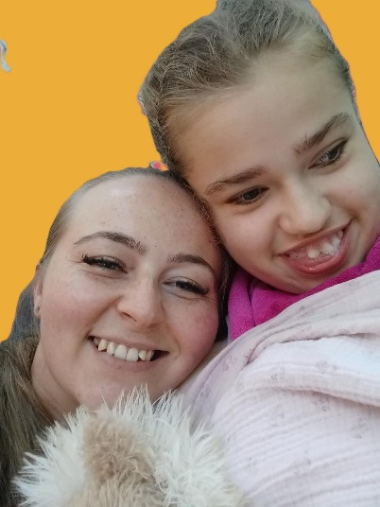 | 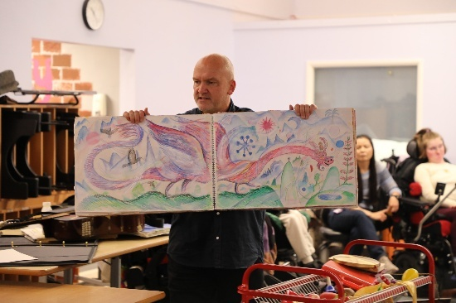 |  | 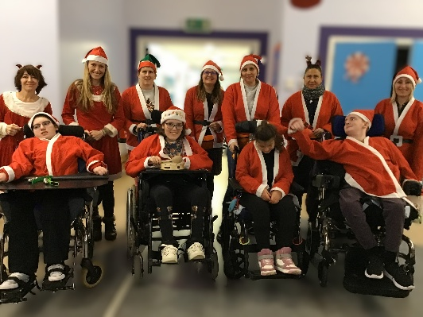 |  |  | 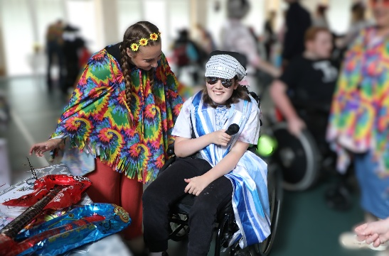
Singer Songwriter Sessions  Hanbury students write their own songs and sing along to them at a weekly gathering, with some old favourites too  PSHE – building confidence, communication skills | Workshops  Live Music  Christmas Crafts  Rock Choir  Pamper Sessions  PSHE – Awareness of the wider environment  Developing communication with a wide range of people |  |  | Patchwork Farm  Our onsite farm provides opportunities for learning and development in all aspects – sensory, communication, engagement, specific learning, social opportunities  PSHE –  Communication with a wide range of people |  | The DREAM Centre  Awards Ceremonies, Rebound, Drama, UV Rave, the Hanbury Pantomime, visiting musicians – the DREAM Centre provides a perfect venue for learning and enrichment opportunities for the Hanbury students  PSHE – building confidence, communication skills
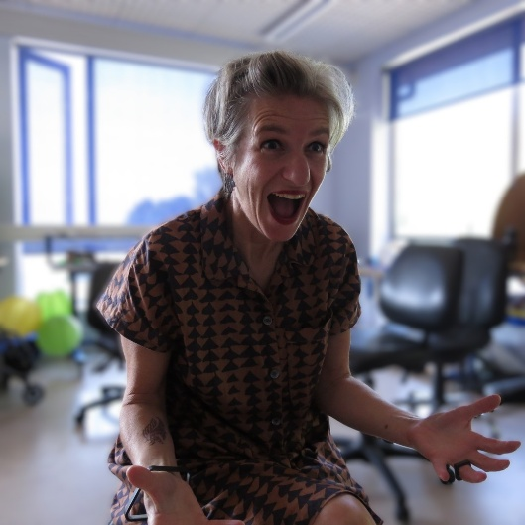 | 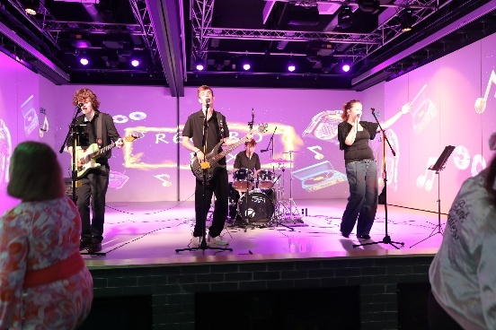 |  |  | 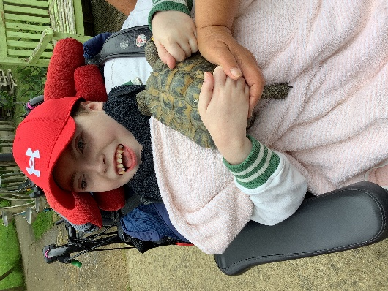 |  | 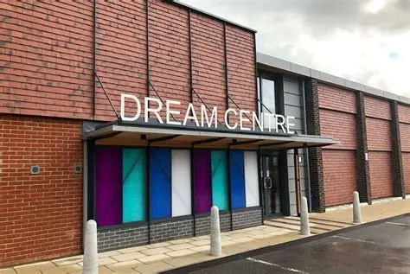

Moving On: Transition to Adult Services (1)  Visits by ex-students and other role models, directed to the needs and interests of Hanbury students  PSHE – communication opportunities – how do I feel about moving on? Awareness of growing from a child into an adult, and what this means for me | Moving On: Transition to Adult Services (2)  Support with visits to Future Placements where appropriate, help with preparation of questions to ask, facilitated discussions about moving on to adult life, help with reflection after visits  PSHE – communication opportunities – the chance to develop curiosity about the world and their place in it | Moving On: Transition to Adult Services (3)  Support and guidance for parents and families throughout their child moving on from Chailey Heritage School. We provide information, advice and guidance, working with external services, facilitating contact between parents, and signposting to other providers | Moving On: Transition to Adult Services (4)  Supported transition between school and post 19 placements whether it is a move to a specialist college, a day centre, or Futures/ LSC at Chailey Heritage Foundation. Help to understand and cope with new places and new relationships PSHE– the chance to develop their knowledge, skills and understanding – to foster their own inner lives
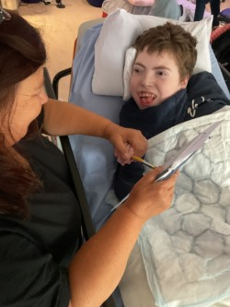 | 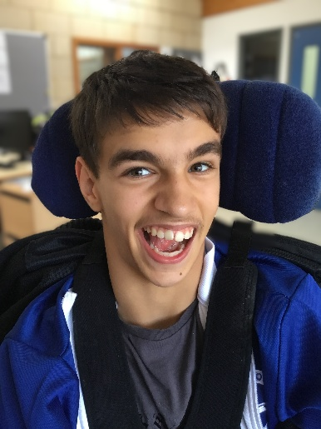 |  | 